TASK 9 - SELENIUM

PROGRAM 1 – To Open the URL:
Program:
public class Program1_OpenURL {

public static void main(String[] args)
{
WebDriver driver = new ChromeDriver();
driver.manage().window().maximize(); //maximize the browser
driver.navigate().to("https://www.google.com/"); //navigate method to navigate to URL
String currentUrl = driver.getCurrentUrl(); //just assigning the current Url to a variable "currentUrl"
System.out.println(currentUrl); //Printing the URL
driver.navigate().refresh(); //Reloading the page
driver.close(); //Closing the current tab/webpage

}

}

Output:
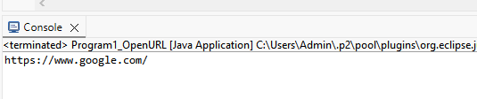

PROGRAM 2 – Verify DEMOBLAZE Title:
Program:
public class Program2_VerifyTitle {

public static void main(String[] args)
{
WebDriver driver = new ChromeDriver();
driver.get("https://www.demoblaze.com");
driver.manage().window().maximize();
String Title = driver.getTitle();
System.out.println(Title);
String Expected_Text = "STORE";
if (Title.equalsIgnoreCase(Expected_Text))
{
System.out.println("Page landed on correct website");
}
else
{
System.out.println("Page not landed on correct website");
};

}

}

Output:

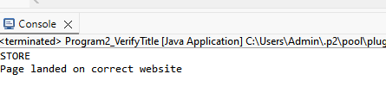

PROGRAM 3 – Navigate WIKIPEDIA History:
Program:
public class Program3_SearchAndClick {

public static void main(String[] args)
{
WebDriver driver = new ChromeDriver();
driver.get("https://www.wikipedia.org/");
driver.manage().window().maximize();
driver.manage().timeouts().implicitlyWait(Duration.ofSeconds(15));
driver.findElement(By.id("searchInput")).sendKeys("Artificial Intelligence");
driver.findElement(By.xpath("//i[@data-jsl10n='search-input-button']")).click();

//(or) driver.findElement(By.id("searchInput")).sendKeys("Artificial Intelligence",Keys.ENTER);

driver.findElement(By.id("toc-History")).click();
String Txt = driver.findElement(By.id("History")).getText();
System.out.println(Txt);

}

}

Output:
